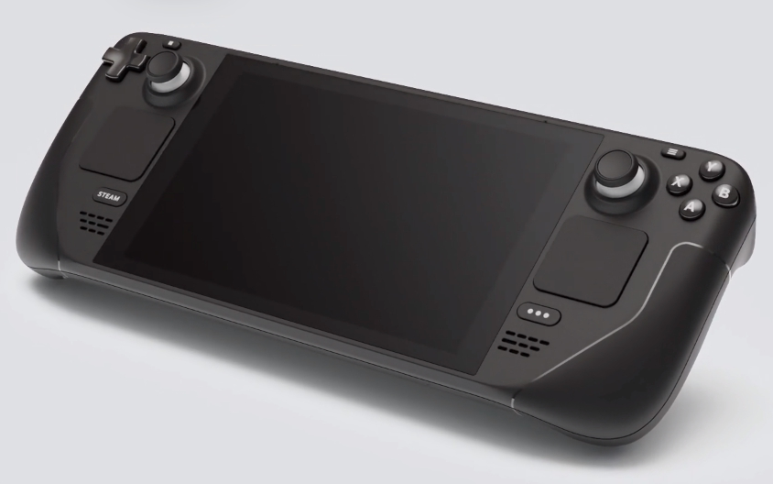
108 - Controls - Gunner - Steam Deck -- WIP
U=Up, D=Down, F=Forward, B=Backward, L=Left, R=Right, P=Press, S-*=Shift-*, L-*=Long-*

D-pad
- U: TADS FOV Wide (LHG)
- D: TADS FOV Zoom (LHG)
- R: TADS FOV Narrow (LHG)
- L: TADS FOV Medium (LHG)
Left stick -- TDC Ministick
- Axes: Sight Manual Tracker ("Thumbforce controller") (RHG)
- P (L3): Store/Update switch STORE (LHG) (Stores selected sensor LOS as a point)
Right Stick
- Axes: Cursor controller (LHG)
- P (R3): Cursor enter (LHG)
- S-P: Cursor display select (LHG)
ABXY buttons
- Y (U): Sight Select HMD (IHADSS) (RHG)
- A (D): Sight Select LINK (RHG) (sets FCR or TADS to LOS of TADS or FCR, depending on which is selected)
- B (L): Sight Select FCR (RHG)
- X (R): Sight Select TADS (RHG)
Left Trackpad
- P: --
Right Trackpad
- P: --
L1 shoulder
- P: --
L2 trigger
- Axis: Fire laser
- P: --
L4 rear button
- P: Shift
L5 rear button
- P: --
R1 shoulder
- P: Sight slave toggle
R2 trigger
- Axis: Fire weapon if in constraints
- P: Fire weapon overriding constraints
R4 rear button
- P: Shift
R5 rear button
- P: --

